GA2015 – XVIII Generative Art Conference
the name(s) of the speaker(s) | TITLE of proposal  TYPE of proposal (Paper, Poster, Artworks, Installation, Live Performance)
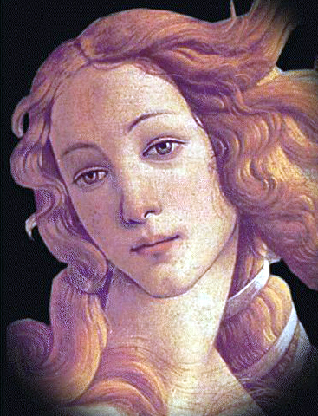  (insert here your portrait)  Topic: (Art, Architecture, Design, Music,...)  Authors:  Name1  University of Nowere, Department of AllTopics  Country  www.myuniversity.net  Name2  University of Nowere, Department of AllTopics  Country  www.mylab.com  Main References:  [1] Name FamilyName, “Title”, Publisher, Where, Year  [2] Name FamilyName, “Title”, Publisher, Where, Year  [3] www.generativeart.com | Abstract:  Please use this template, without changing it in the dimension of spaces, table and characters, for sending your abstract to GA2015, XVIII Generative Art conference following the deadline written in the website.  You can use this for the abstract of your paper but also for your poster, for your artworks or installation and for your live performance. Please insert your type of contribution in the title.  On the top of left columns you can insert your photo (or your portrait if you don't like to communicate your photo). If the people coming to GA conference and presenting your work are more than one you can insert all the photos one over the other with all the names in the left column. Better, you can use a photo of the group.  Then, follow the template for inserting the topic of your work (Art, Music, Architecture, Industrial Design, Web Art, Poetry, Teaching Theory, Mathematics, Artificial Life, Cellular Automata, Generative Robots, ....) and the names of the authors, the affiliation and so on in the left column. References will be only the most important. And you go on until filling the preferred contact in the bottom space.  On the right column you can insert your text followed (if you like) by all the images that you need but, please, insert the images directly in the text without using frames or other devices. Please do not change the character ARIAL and the dimension 11.  You can send this abstract with 2 files (.doc and .pdf file) to the Chair of GA conferences celestino.soddu@generativeart.com  PLEASE, DON’T CHANGE THE FORMAT AND USE ONLY ONE PAGE!  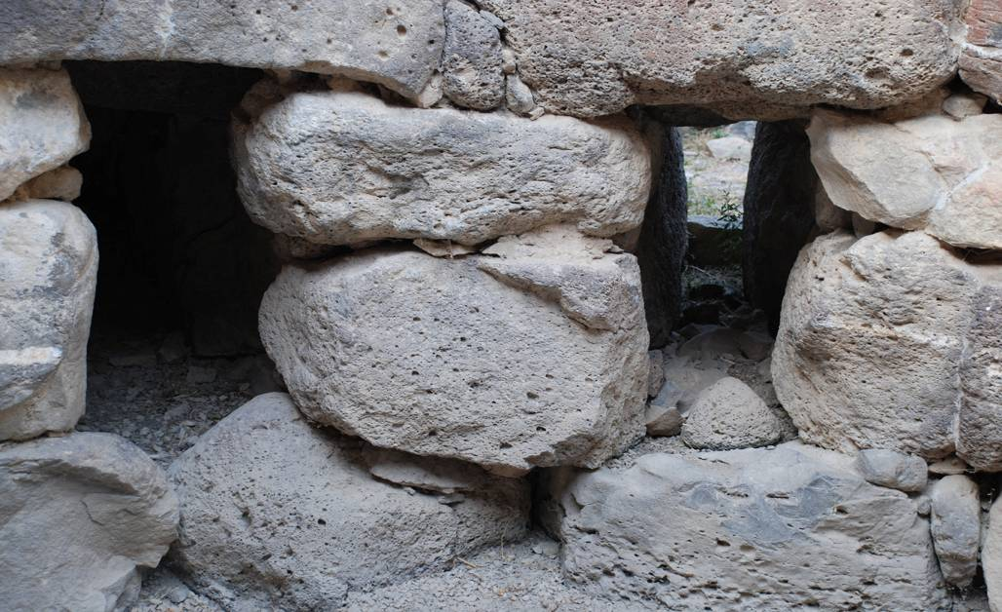  Example: Image of Nuraghe in Sardinia
Contact: email | Keywords:  One, two, three, four, five, six, seven

